
JAVA PROJECT REPORT ON
Hostel Room Allocation and Student Stay Management System

Submitted by
MAHALAKSHMI R
25BCS034

Under the Guidance of
Dr.BOOPALAN SUNDARAMOORTHY
Technical Head
Technical Department, KG College of Arts and Science

Academic Year: 2025 – 2026
APRIL 2026
Semester: II

DECLARATION
I hereby declare that the project entitled “Hostel Room Allocation and Student Stay Management System” submitted in partial fulfillment of the requirements for the course JAVA PROGRAMMING LANGUAGE is a record of my original work carried out under the guidance of Dr.BOOPALAN SUNDARAMOORTHY,, Technical Head, Technical Department, KG College of Arts and Science.
I further declare that this project has not been submitted previously, either in part or in full, for the award of any degree, diploma, or other similar title, at this or any other institution.
I have acknowledged all sources of information used in this project wherever applicable.

April 2026
Coimbatore

MAHALAKSHMI R ________________________
(Your Name)

CERTIFICATE

This is to certify that the project entitled “Hostel Room Allocation and Student Stay Management System” is a bona fide work carried out by MAHALAKSHMI R, I - ‘A’(2025 - 2028), Department of Computer Science, KG College of Arts & Science, in partial fulfillment of the requirements for the course JAVA PROGRAMMING LANGUAGE.
This project has been completed under my supervision and guidance during the academic period April 2026.

Place: Coimbatore
Date:10/04/2026

Submitted for the Viva-Voce Examination held on 10/05/2026

Guide: Head of the Department
(Technical Head, KGCAS) (Technical Head, KGCAS)

______________________ _______________________

TABLE OF CONTENTS
S. No. | Topics | Page. No.
1 | Introduction
1.1 | Objective
1.2 | Overview
1.3 | Features
2 | Program Analysis
2.1 | Problem Definition
2.2 | Project Overview
2.3 | Scopes and Limitations
3 | System Design
3.1 | Modules
4 | Methodology
4.1 | Problem Analysis
4.2 | System Design
4.3 | Program Development
4.4 | Testing and Validation
4.5 | Result and Documentation
4.6 | Algorithm
4.7 | Flowchart
5 | Source Code
6 | Input and Output Screens
7 | Discussion and Conclusion
7.1 | Discussion
7.2 | Conclusion
8 | References

ABSTRACT

The Hostel Room Allocation and Student Stay Management System is a software application developed using Java to simplify and automate the management of hostel rooms and student accommodation. The system is designed to efficiently handle room allocation, student check-in and check-out processes, and maintain accurate records of student stay details.
This application helps in reducing manual work by automatically assigning rooms based on availability and capacity. It also allows the administrator to view room occupancy, track student information, and monitor the duration of stay. Additional features such as student search, room status display, and vacancy management make the system more efficient and user-friendly.
The system is built using Object-Oriented Programming (OOP) concepts, ensuring modularity, scalability, and ease of maintenance. It can be further enhanced by integrating a database, graphical user interface, and advanced features like online booking and real-time monitoring.
Overall, this project provides a simple, efficient, and reliable solution for hostel management, making the process faster, more organized, and less error-prone.

- INTRODUCTION

Managing hostel rooms and student accommodation is an important task in colleges and institutions. In many hostels, room allocation, student records, and check-in/check-out processes are handled manually using registers or basic methods. This manual system can lead to errors in room allocation, difficulty in tracking student details, and delays in managing hostel activities.
With the advancement of technology, automated systems have become necessary to improve efficiency and accuracy in hostel management. A computerized system helps in maintaining student records, tracking room availability, and managing check-in and check-out processes in an organized manner.
The Hostel Room Allocation and Student Stay Management System is a Java-based application developed to automate these tasks. The system allows the user to allocate rooms to students based on availability, manage student details, and handle check-in and check-out operations efficiently. It also provides features such as searching student records, viewing room status, and tracking the duration of student stay.
This project is developed using Core Java programming concepts such as classes, objects, methods, loops, conditional statements, and collections. The system provides a simple and user-friendly interface, making it easy to use for hostel administrators.
The main purpose of this system is to reduce manual work, minimize errors, and improve the overall efficiency of hostel management. It also demonstrates the practical application of Java programming in real-world scenarios.

1.1 Objective
The main objective of the Hostel Room Allocation and Student Stay Management System is to develop a simple and efficient system to manage hostel rooms and student accommodation.

The specific objectives of this project are:
- To manage student details such as ID, name, and stay duration
- To allocate rooms automatically based on availability and capacity
- To handle student check-in and check-out processes efficiently
- To reduce manual errors in room allocation and record maintenance
- To provide a user-friendly system for hostel administration
- To track room occupancy and availability status
- To search and manage student records easily
- To demonstrate the practical implementation of Core Java programming concepts

1.2 Overview
The Electronic Store Product Catalog and Sales Management System is a menu-driven application developed using Java programming language. It is designed to simplify the management of products and billing operations in electronic stores.
The system allows users to maintain a product catalog by adding, updating, deleting, and searching product details such as name, price, and quantity. It also enables efficient handling of customer purchases by allowing users to select products and enter the required quantity.
The application automatically calculates the total bill by adding the prices of selected products and applying discounts and GST. It then generates a clear and organized invoice showing product details, quantity, price, tax, and final payable amount.
This system reduces manual effort, minimizes errors, and helps maintain proper records of products and sales. It can be implemented as a console-based application and can also be enhanced with a graphical user interface using Java Swing.
Overall, this project demonstrates the practical application of Core Java programming concepts in developing real-world retail management systems.
.

1.3 Features
The Hostel Room Allocation and Student Stay Management System provides several useful features to simplify hostel management and improve efficiency. The key features of the system are:
- Room Allocation System
Automatically allocates rooms to students based on availability and room capacity.
- Student Record Management
Allows adding, viewing, and managing student details such as ID, name, room number, and stay duration.
- Check-in and Check-out Management
Handles student entry (check-in) and exit (check-out) while updating room availability accordingly.
- Room Availability Tracking
Displays the current status of rooms, including occupied and vacant rooms.
- Search Functionality
Enables searching of student details using student ID for quick access.
- Room Capacity Management
Ensures that rooms are not over-allocated beyond their capacity.
- User-Friendly Interface
Provides a simple menu-driven interface that is easy to use for hostel administrators.
- Data Management using Collections
Uses Java collections like ArrayList to efficiently store and manage data.
- Error Reduction
Minimizes manual errors in room allocation and record maintenance.
- Scalability
Can be easily enhanced by adding features like database integration or GUI.

- PROGRAM ANALYSIS
The Hostel Room Allocation and Student Stay Management System is developed to automate the process of managing hostel rooms and student accommodation efficiently. The system is designed using Java programming language and follows a structured approach using Object-Oriented Programming concepts.

System Analysis
In traditional hostel management, room allocation and student records are maintained manually, which may lead to errors, data loss, and inefficient handling of room availability. This system analyzes these problems and provides a computerized solution to overcome them.
The system ensures proper allocation of rooms based on availability and capacity, avoiding over-allocation. It also maintains accurate student records and updates room status dynamically during check-in and check-out processes.

Functional Analysis:
The main functionalities of the system include:
- StudentDataManagement:
The system stores and manages student details such as ID, name, room number, and duration of stay.
- RoomLogic:
Rooms are allocated automatically by checking available rooms and their capacity.
- Check-inProcess:
When a student enters the hostel, the system assigns a room and updates occupancy.
- Check-outProcess:
When a student leaves, the system removes the student record and frees the room.
- SearchOperation:
Allows quick retrieval of student details using student ID.
- RoomStatusMonitoring:
Displays current occupancy and availability of rooms.

Technical Analysis:
The system is implemented using the following concepts:
- Object-OrientedProgramming(OOP):
Classes like Student and Room are used to represent real-world entities.
- CollectionsFramework:
ArrayList is used to store and manage student and room data dynamically.
- ControlStructures:
Loops and conditional statements are used for decision-making and flow control.
- Menu-DrivenApproach:
Provides an interactive interface for users to perform operations easily.

2.1 Problem Definition
In many colleges and institutions, hostel management is still handled manually using registers or basic record-keeping methods. This manual approach creates several challenges in managing room allocation and student accommodation efficiently.
The process of assigning rooms to students becomes difficult when there are many students and limited rooms. Manual allocation may lead to errors such as assigning the same room to multiple students or exceeding room capacity. It is also hard to keep track of which rooms are occupied and which are available at any given time.
Maintaining student records manually is time-consuming and increases the chances of data loss or incorrect entries. Searching for specific student information, such as room number or duration of stay, becomes slow and inefficient. Additionally, handling check-in and check-out processes manually can lead to confusion and improper record updates.
There is also a lack of proper tracking of student stay duration and room usage, making it difficult for hostel administrators to manage resources effectively. Generating reports on room occupancy and student details is not easy in a manual system.
Therefore, there is a need for an automated system that can efficiently manage hostel room allocation, maintain accurate student records, and simplify check-in and check-out operations. The proposed system aims to solve these problems by providing a reliable, fast, and error-free solution using Java programming.

2.2 Project Overview
The Hostel Room Allocation and Student Stay Management System is a Java-based application developed to simplify and automate hostel management activities. The system focuses on efficient handling of room allocation, student record management, and stay tracking within a hostel environment.
This project provides a structured way to manage hostel operations by replacing manual record-keeping methods with a computerized system. It allows the administrator to allocate rooms to students based on availability and capacity, ensuring proper utilization of hostel resources. The system also maintains detailed records of students, including their ID, name, room number, and duration of stay.
The application supports essential operations such as student check-in and check-out, which automatically update room occupancy status. It also includes features like searching for student details, viewing room availability, and monitoring occupancy levels. These functionalities help in reducing errors and improving the overall efficiency of hostel management.
The system is developed using Core Java concepts such as classes, objects, methods, loops, and collections, making it simple, modular, and easy to maintain. It follows a menu-driven approach, providing a user-friendly interface for smooth operation.
Overall, this project demonstrates how software solutions can be used to manage real-world problems effectively. It improves accuracy, saves time, and provides better control over hostel operations, making it a reliable system for managing student accommodation.

2.3 Scopes and Limitations

Scope

Scope of the System
The Hostel Room Allocation and Student Stay Management System is designed to provide an efficient and organized solution for managing hostel operations. The scope of the system includes:
- Room Allocation Management
Automatically assigns rooms to students based on availability and capacity.
- Student Information Management
Maintains records of students including ID, name, room number, and duration of stay.
- Check-in and Check-out Handling
Supports smooth entry and exit of students while updating room occupancy.
- Room Status Monitoring
Displays current room occupancy, available rooms, and total capacity.
- Search and Retrieval
Allows quick access to student details using student ID.
- Efficient Data Handling
Uses Java collections to manage data dynamically during program execution.
- Extendable System
Can be enhanced with database integration, GUI, and advanced features like online booking.

Limitations
Despite its usefulness, the system has some limitations:
- No Permanent Data Storage
Data is not stored permanently (no database); information is lost when the program stops.
- Console-Based Interface
The system uses a text-based interface, which is less interactive compared to GUI applications.
- Limited Features
Does not include advanced features like online booking, payment system, or notifications.
- Single User Access
Designed for use by one administrator at a time (no multi-user support).
- Basic Security
No authentication or login system is implemented.

- SYSTEM DESIGN
The Hostel Room Allocation and Student Stay Management System is designed as a simple Java-based application to manage hostel rooms and student accommodation efficiently. The system follows a modular structure for easy operation and maintenance.

System Modules
• Student Module – Add, view, search, and manage student details
• Room Module – Maintain room number, capacity, and occupancy
• Allocation Module – Automatically assign rooms based on availability
• Check-in/Check-out Module – Handle student entry and exit operations
• Data Handling Module – Store and manage data using collections (ArrayList)

Working Process
- User selects an operation from the menu
- System processes the request (allocation / search / checkout)
- Data is stored or retrieved from memory (ArrayList)
- Output is displayed to the user
- Room occupancy is updated automatically

Design Approach
The system is developed using Java and follows basic OOP concepts like encapsulation, abstraction, and modular design for better structure and maintainability. It uses a menu-driven approach to ensure easy interaction for the user.

3.1 Modules

1. Login Module
This module provides basic access control to the system. It allows the administrator to log in using a username and password.

Functions of this module include:
• Accepting username and password
• Validating user credentials
• Allowing access only for authorized users

Example:
Username: admin
Password: 1234

2. Student Management Module
This module is used to manage student details in the hostel.

Functions of this module include:
• Adding new student details
• Displaying student information
• Storing details like ID, name, room number, and stay duration

3. Room Management Module
This module handles all room-related information.

Functions of this module include:
• Maintaining room number and capacity
• Tracking number of occupied and available rooms
• Preventing over-allocation of room

4. Allocation Module
This module is responsible for assigning rooms to students.

Functions of this module include:
• Allocating rooms automatically based on availability
• Assigning rooms without exceeding capacity
• Displaying allocated room details

5. Check-In/Check-Out Module
This module manages student entry and exit in the hostel.

Functions of this module include:
• Handling student check-in process
• Handling student check-out process
• Updating room occupancy after check-out

6.Search Module
This module helps in finding student details quickly.

Functions of this module include:
• Searching students by ID
• Displaying matching student details
• Providing quick access to records

7. Data Handling Module
This module is responsible for managing data in the system.

Functions of this module include:
• Storing student and room data using ArrayList
• Managing data during program execution
• (Optional) Can be extended to file handling or database

8. Exit Module
This module is used to safely close the application
Functions of this module include:
• Terminating the program properly
• Ensuring all operations are completed before exit

- METHODOLOGY

The Hostel Room Allocation and Student Stay Management System is developed using a structured and step-by-step approach to ensure efficient hostel management. Initially, the problems in manual room allocation and record maintenance are analyzed. Based on this, the system is designed using different modules such as student management, room management, allocation, and check-in/check-out.
The implementation is done using Java programming language with Object-Oriented Programming concepts like classes and objects. A menu-driven approach is used to make the system easy to operate. The user selects an option, provides the required input, and the system processes the request and displays the output.
Data is stored and managed dynamically using collections like ArrayList. The system is tested with different inputs to ensure accuracy in room allocation and proper handling of student records.
This methodology helps in reducing manual errors, improving efficiency, and providing a simple and reliable solution for hostel management.

4.1. Problem Analysis
In many hostels, room allocation and student record management are done manually using registers. This manual system creates several issues in managing hostel operations efficiently.
One of the main problems is difficulty in allocating rooms when the number of students increases. There is a high chance of errors such as assigning the same room to multiple students or exceeding room capacity. It is also difficult to track which rooms are occupied and which are available.
Maintaining student details manually is time-consuming and may lead to data loss or incorrect entries. Searching for specific student information becomes slow and inefficient. Handling check-in and check-out processes manually can also cause confusion and improper updates in records.
Additionally, there is no proper system to track student stay duration and room usage. Generating reports or checking room status becomes difficult in a manual system.
Therefore, there is a need for an automated system that can manage room allocation, maintain student records, and handle hostel operations accurately and efficiently.
4.2. System Design
In this stage, the overall structure of the system is designed before coding begins.
The system is divided into modules such as:
• Login Module
• Student Management Module
• Room Management Module
• Allocation Module
• Check-in / Check-out Module
• Search Module
• Data Handling Module
• Exit Module
The program flow and structure are designed so that users can easily interact with the system. The interface is simple and user-friendly, allowing efficient management of student records, room allocation, and hostel operations.
4.3. Program Development
In this stage, the actual coding of the system is carried out based on the system design. The Hostel Room Allocation and Student Stay Management System is developed using Java programming language.
The program is divided into different classes such as Student and Room to represent real-world entities. Each module like student management, room allocation, check-in/check-out, and search is implemented using separate methods for better organization.
Core Java concepts such as classes, objects, methods, loops, conditional statements, and collections (ArrayList) are used to develop the system. The program follows a menu-driven approach, allowing users to select operations easily and perform tasks efficiently.
The logic for room allocation checks for available rooms and assigns them without exceeding capacity. Similarly, the check-out process updates room occupancy correctly. All data is stored and managed dynamically during program execution.
Overall, the program is developed in a simple, modular, and efficient manner, ensuring easy understanding, maintenance, and execution.
4.4. Testing and Validation
Testing ensures that the Hostel Room Allocation and Student Stay Management System works correctly and produces the expected results. Different test cases were used to verify the functionality of the system.
Example Test Cases:

Test Case | Expected Result
Login with valid details | Access granted
Login with invalid details | Error message displayed
Add student details | Student added successfully
Allocate room | Room assigned based on availability
Room full condition | Display "No rooms available" message
Search student | Correct student details displayed
Check-out student | Room is freed and record removed
View room status | Correct occupancy details shown
Invalid input | Error handled properly
4.5. Result and Documentation
After successful testing, the results of the Hostel Room Allocation and Student Stay Management System are documented. The system efficiently manages student and room data, including student ID, name, room number, stay duration, and room occupancy, and performs operations like room allocation, check-in, check-out, search, and room status tracking effectively.
The results are demonstrated through program execution and screenshots showing the login screen, student management interface, room allocation process, and room status display.
Proper documentation is prepared to explain the design, implementation, and working of the system, making it easy for users and evaluators to understand the functionality and flow of the application.
4.6. Algorithm

Algorithm for the Hostel Room Allocation and Student Stay Management System:
- Start the program
- Display the login screen
- Enter username and password
- Validate login credentials
- If valid, open the main system; otherwise, show error message
- Display options: Add Student, Allocate Room, Search Student, Check-out, View Students, Room Status
- If adding student, enter student details (ID, name, stay duration) and save to system
- If allocating room, check available rooms and assign room based on capacity
- If searching, enter student ID and display student details
- If check-out, enter student ID, remove record, and update room availability
- Display student details or room status when selected
- Store and manage data using collections (ArrayList)
- Display confirmation message for each operation
- End the program

4.7. Flowchart
Flowchart for Hostel Room Allocation and Student Stay Management System :

START
↓
Login Screen
↓
Enter Username & Password
↓
Valid?
┌───────────────┐
│ Yes │ No
↓ ↓
Main Menu Show Error
↓ ↓
Select Option ←───┘
↓
┌──────────────────────────────┐
│ 1. Add Student │
│ 2. Allocate Room │
│ 3. Search Student │
│ 4. Check-out │
│ 5. View Students │
│ 6. Room Status │
│ 7. Exit │
└──────────────────────────────┘
↓
Perform Selected Operation
↓
Update Data (ArrayList)
↓
Display Result
↓
Back to Menu?
┌───────────────┐
│ Yes │ No
↓ ↓
Menu END

- SOURCE CODE

1. Student Class
• Represents each student with id, name, room number, and stay duration
• Stores student details when room is allocated

class Hostel {

// 🔹 Student Class
static class Student {
int id;
String name;
int roomNo;
int days;

Student(int id, String name, int roomNo, int days) {
this.id = id;
this.name = name;
this.roomNo = roomNo;
this.days = days;
}
}

// 🔹 Room Class
static class Room {
int roomNo;
int capacity;
int occupied;

Room(int roomNo, int capacity) {
this.roomNo = roomNo;
this.capacity = capacity;
this.occupied = 0;
}
}
}

2. Main Class & Menu
• Main loop provides options for Add Student, Allocate Room, View Students, Search Student, Check-out, Room Status, and Exit.
• Uses Scanner for user input and ArrayList<Student> and ArrayList<Room> to store student and room data.

3. Login Module
• Simple login check: username = admin and password = 1234
• Program exits if invalid login

Scanner sc = new Scanner(System.in);
System.out.print("Enter Username: ");
String u = sc.nextLine();
System.out.print("Enter Password: ");
String p = sc.nextLine();
if (!(u.equals("admin") && p.equals("1234"))) {
System.out.println("Wrong Login!");
System.exit(0);
}
System.out.println("Login Successful!");

4. Add Student And Allocacate Room

Student s = new Student(id, name, r.roomNo, days);
students.add(s);

• Takes student ID, name, and stay duration from user
• Allocates room based on availability and adds to student list

5. View Student
for (Student s : students) {

System.out.println(s.id + " " + s.name +
" Room: " + s.roomNo + " Days: " + s.days);
}

• Displays all student details in structured format
• Shows ID, Name, Room Number, and Stay Duration

6. Search Student

for (Student s : students) {

if (s.id == id) {
System.out.println("Found: " + s.name +
" Room: " + s.roomNo);
return;
}
}

• Searches student using ID
• Displays matching student details

7. Check-out student

- Iterator<Student> it = students.iterator();
while (it.hasNext()) {
Student s = it.next();
if (s.id == id) {
it.remove();
System.out.println("Checked out!");
return;
}
}
• Removes student from list
• Frees allocated room

8. Room Status
for (Room r : rooms) {

System.out.println("Room " + r.roomNo +
" -> " + r.occupied + "/" + r.capacity);
}

• Displays room occupancy details
• Shows available and occupied rooms

- INPUT AND OUTPUT SCREENS
Include screenshots of:
Login
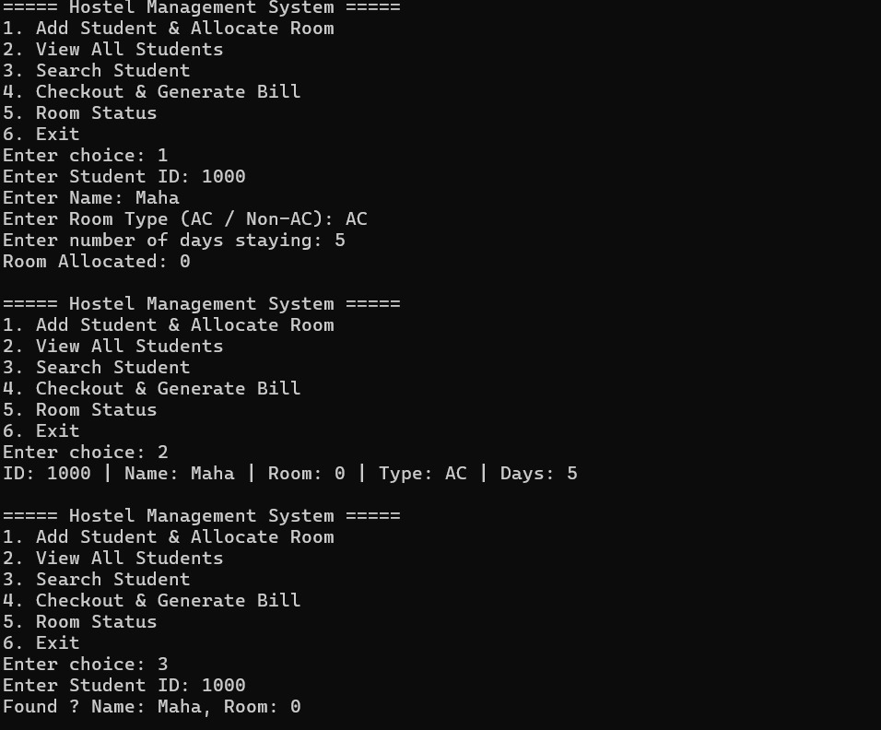

Main Application Window
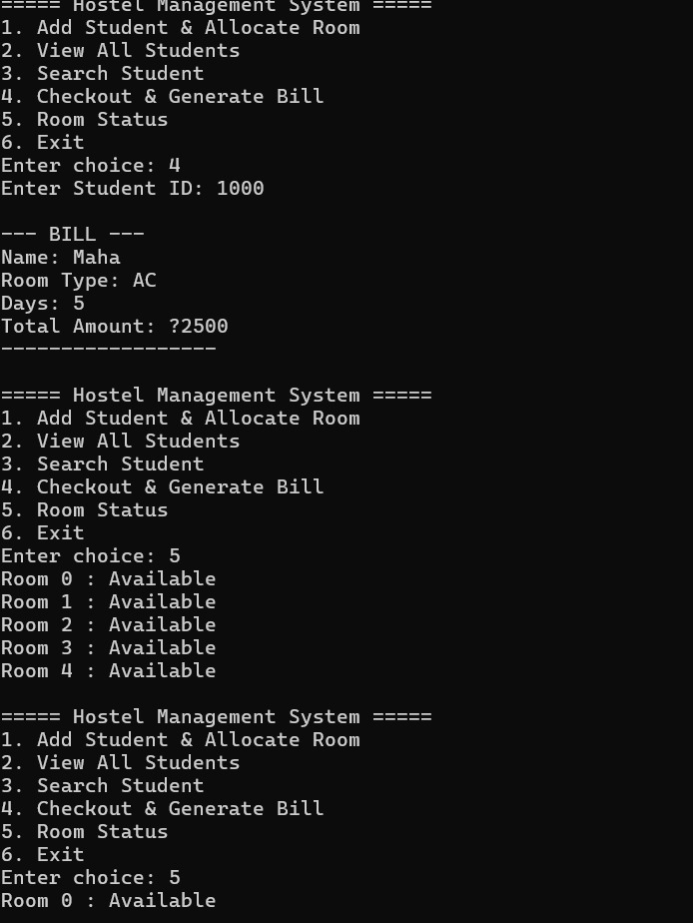

Search Functionality

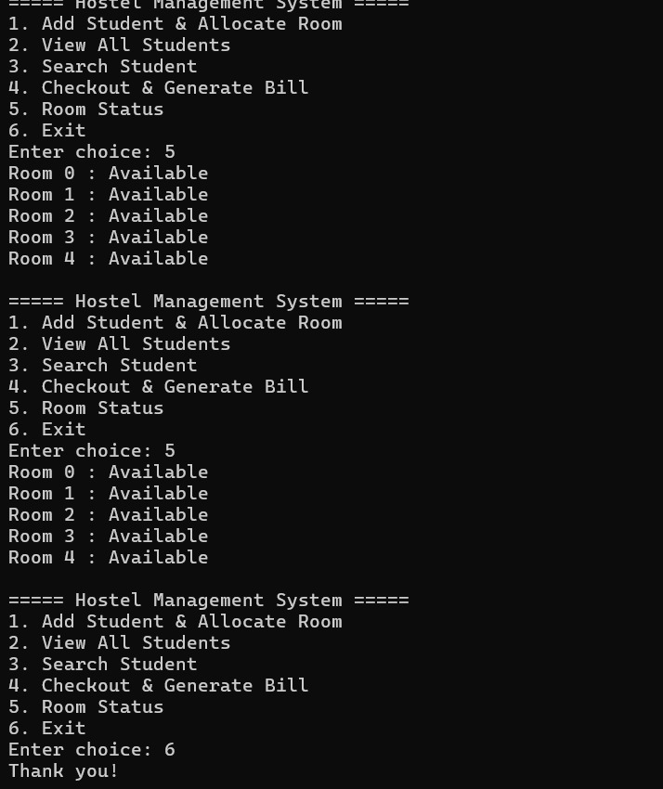

Each screenshot should be labeled.

Example:
Figure 1: Login Screen
Figure 2: Main Dashboard
Figure 3: Student Registration
Figure 4: Room Allocation Form
Figure 5: Room Availability Status
Figure 6: Student Details View
Figure 7: Search Student Record
Figure 8: Fee Payment Entry
Figure 9: Data Saved Confirmation Message
Figure 10: Logout Screen

- DISCUSSION & CONCLUSION

7.1 Discussion
The Hostel Room Allocation and Student Stay Management System was developed to overcome the difficulties faced in manual hostel management. The system was designed and implemented using Java, focusing on simplicity and efficiency.
During development, different modules such as student management, room allocation, search, and check-in/check-out were implemented and tested. The system was able to allocate rooms correctly based on availability and capacity, ensuring that no room is overfilled. It also maintained accurate student records and updated room status dynamically.
The menu-driven approach made the system easy to use, and the use of ArrayList helped in managing data efficiently during execution. Testing with various inputs showed that the system performs all operations correctly and handles errors properly.
Overall, the system successfully meets the basic requirements of hostel management and provides a reliable solution.

7.2 Conclusion
The Hostel Room Allocation and Student Stay Management System is successfully developed using Java to automate hostel operations. The system efficiently manages student records, room allocation, and occupancy tracking.
It reduces manual work, minimizes errors, and improves the overall efficiency of hostel management. The application is simple, user-friendly, and easy to maintain.
Although the system is console-based and has some limitations, it provides a strong foundation for further enhancements such as database integration, graphical user interface, and advanced features.
In conclusion, this project demonstrates the practical implementation of Java programming in solving real-world problems and provides an effective solution for managing hostel activities.

Future Enhancements
- Add GUI (Swing/JavaFX) for better interface
• Use database (MySQL) for permanent storage
• Implement online room booking
• Add fee management system
• Provide admin/user login roles
• Generate reports & notifications

- REFERENCES

• Java Programming – E. Balagurusamy
• Core Java Volume I – Herbert Schildt
• Oracle Corporation – Official Java Documentation (docs.oracle.com)
• GeeksforGeeks – www.geeksforgeeks.org
• W3Schools – www.w3schools.com

